In summary
To greatly reduce issues please make sure you have the following configuration:

- All units should be running version 3.79 of the Karlnet software. Mixed versions of the software are not recommended.
- Radio firmware in all radios upgraded to 6.08.
- Use of the Karlnet configuration software version 3.64.
- All of these files can be downloaded from the Karlnet license-it website.
http://www.license-it.com/ISP_download_files_main.asp

Checking Software Version

The software running on the access points must be at version 3.70 or higher. To check the version you are currently running, perform the following steps.

- Start the Configuration program.

- Select Remote Statistics from the Monitor menu.
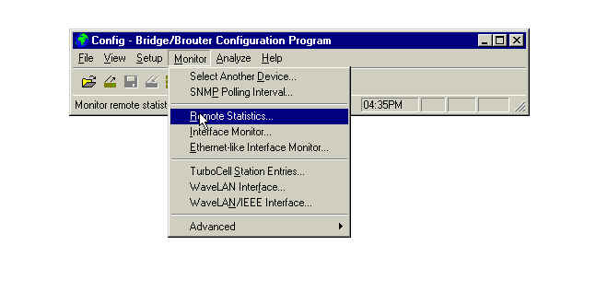
- It may be necessary to scan for the correct IP address. If so, the procedure is the same as the one used in the installation process.

- The statistics for the remote device will display and look similar to the following:
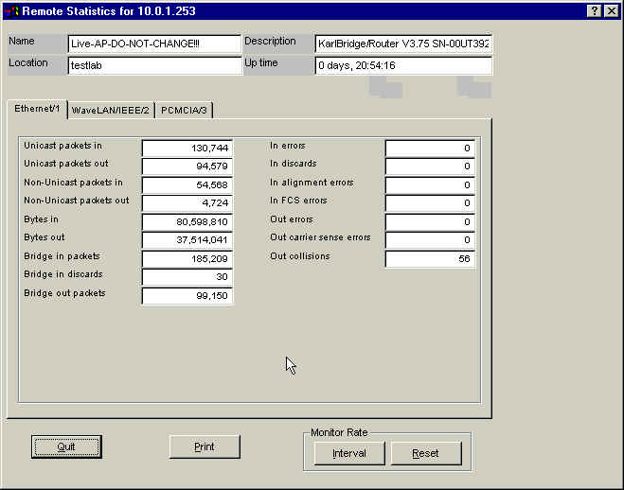

The box named Description shows the version number of the software loaded on the device. If it does not indicate 3.70 or higher, you will need to reload with the correct version.

Karlnet Software

Upload Procedure

Copyright 2001 – KarlNet, Inc.

Uploading the Configuration File – Part 1 (Loading the ‘bin’ file)

Note: This procedure assumes the hardware unit has been properly set up, all cables attached, and the device is powered on.

- 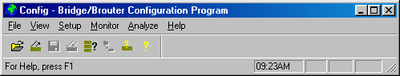Once the device is ready, start the Configurator program on the workstation you are using for this procedure.

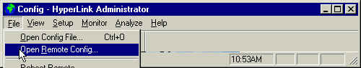
- Select Open Remote Config… from the File dropdown menu.

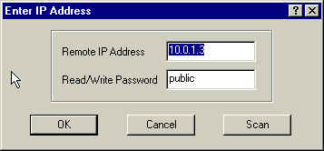
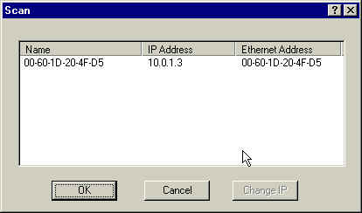
- Perform the scan function to determine the MAC address of the device. Be sure to copy the address correctly as it is needed to generate the key necessary to load the file.

- Switch to the program used to generate the key (http://206.21.0.66) and follow the directions supplied with the program. Copy the key correctly (Notepad is a handy place to store this information) then return to the Configurator program.

- Open the configuration file in the Configurator (File -> Open Config File...).
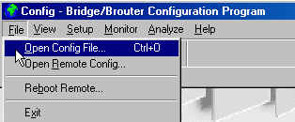

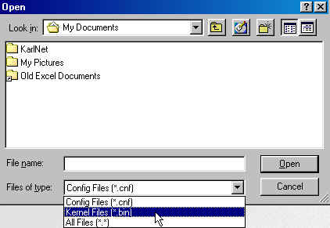
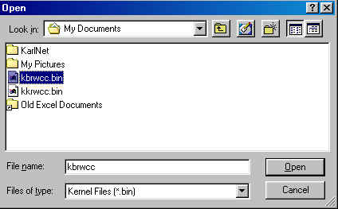
- Select the location (drive) of the file. The file has an extension of .bin, so you will need to change the file type in the Open window, then select the appropriate file from the list displayed.
Kernel file
File extensions
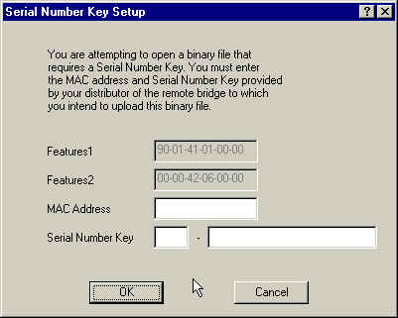
- Enter the MAC address and serial number key that has been generated for this device.

- When the file is opened, the title bar of the Configurator window will change to the name of the kernel file that has been opened. (Example may not match actual file you are installing.)
Kernel file name
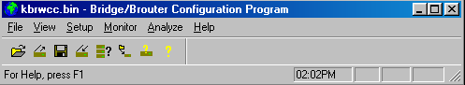

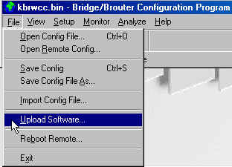
- After the file is opened, upload the it to the device (File -> Upload Software).

- You will get a series of messages similar to the following after selecting Upload Software. Click Yes at the first two messages and OK at the last message to complete the upload.
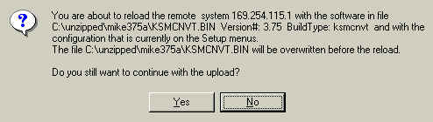
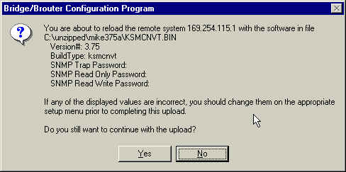
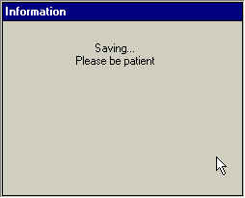
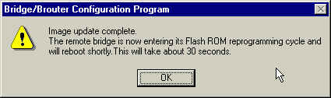

Uploading the Configuration File – Part 2 (Changing the IP Address)

Note: The devices must be installed, and this part of the configuration completed, one device at a time. When the file was loaded into the device in the previous section, the same IP address was given to each one. Therefore, if a second device is installed before completing all steps in this section, results are unpredictable.

- After the device is connected to the network, powered on and ready, start the Configurator program on the workstation you are using for the procedure. (See step 1 in the previous section.)

- Select Open Remote Config from the File dropdown menu. (See step 2 in the previous section.)

- Perform the Scan function to display the IP address of the device.
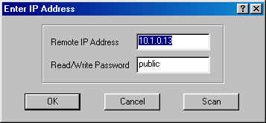
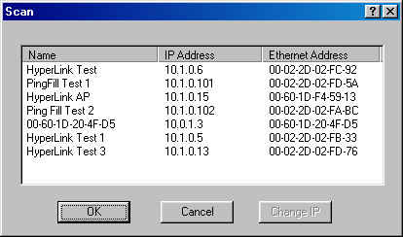
- Click on the name of the device listed with an IP address of 198.17.74.254, then click the Change IP button.

Note: This procedure has already been completed for all devices shown in the above list. If a new device were added to the network that had been through the steps in Part 1, the IP address of 198.17.74.254 would be displayed.

- Enter the IP address to be used for the device.

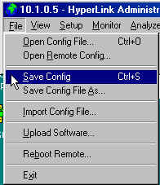
- Select Save Config from the File dropdown menu.

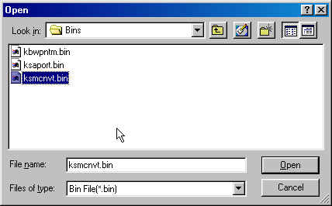
- Select Upload Software from the File dropdown menu. Select the file to upload, then click Open.

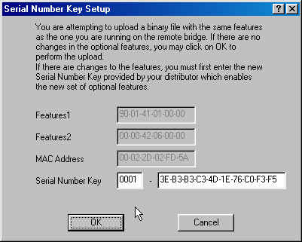
- You will also see a window similar to the following:

As no features have been changed, click OK.

- You will see a series of messages similar to the following. Click Yes at the first two messages and OK at the last message to continue with the upload.
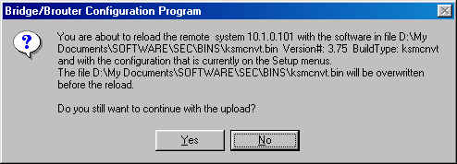
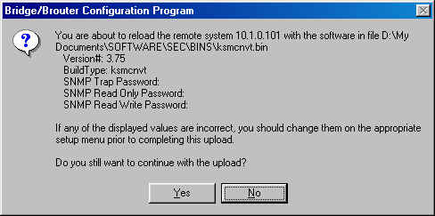

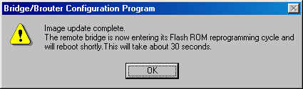
- Repeat steps for each device.

Loading Lucent Firmware onto the Orinoco Radio Cards.
Note: The latest firmware with the most field test success is version 6.08. You can obtain it from http://www.karlnet.com/download/wsu608_or_a.exe on the Karlnet website.

Warning! Once you upload a newer version of the firmware onto a card, you cannot back down to a previous version!

1. Unzip the file to a temporary directory and then double click on the program to start.
2. Click the Update button to start the upgrade process;
3. When finished, click the Close button to close the program.

Key program
Keys are generated on the website at 206.21.0.66.

Configuration software
The latest configuration software commonly referred to as the ‘configurator’ is 3.64. It can be downloaded from http://www.karlnet.com/download/configsetup.exe on the Karlnet website. Using a configuration software version below 3.64 will result in errors.

To ensure that you are using the latest configuration software, click on Help and then About to determine the
version that you are using.

TurboCell
COMMUNICATIONS CHART

Use: TurboCell software is an Fixed Wireless protocol developed by KarlNet, Inc. It uses the 802.11b radios, but is not part of the 802.11b standard. It’s primary use is for WANs, connecting networks located up to 25 miles apart from one another.

Connection Matrix:

 | TurboCell ISP Base | TurboCell Base | TurboCell Satellite | TurboCell Client
TurboCell ISP Base | NO | NO | YES | YES
TurboCell Base | NO | NO | YES | NO
TurboCell Satellite | YES | YES | 1 user PTP link only | NO
TurboCell SOHO | YES | YES | 1 user PTP link only | NO
TurboCell Client | YES | NO | NO | NO

- TurboCell ISP Base – Karlnet Software which is equivalent to the COR, but also includes RADIUS server support, and protocol filters. Normally is connected to an Omni Antenna and is centrally located. The bin file is the TC-AP-ISP-Base.bin for the AP-1000 or the TC-FlashROM-ISP-Base.bin for the Flashrom Kit.
- TurboCell Base- Karlnet Software which is the equivalent to the COR. Normally is connected to an Omni Antenna and is centrally located. The bin file is the TC-AP-Base.bin for the AP-1000 or the TC-FlashROM-Base.bin for the Flashrom Kit.
- TurboCell Satellite- Karlnet Software which is equivalent to the ROR. Normally is connected to a Directional Antenna and is one of the end points. The bin file is the TC-AP-Sat.bin for the AP-1000, the TC-RG-Sat.bin for the RG-1000or the TC-FlashROM-Sat.bin for the Flashrom Kit.
- TurboCell SOHO- Karlnet Software which is a low cost version of ROR. Is limited to up to 5 users. Is Normally connected to a Directional Antenna and is one of the end points. The bin file is the TC-RG-SOHO.bin for the RG-1000.
- TurboCell Client-Is the driver for a radio in a PC. The bin file is TC-Card and then the O/S that is on the PC..

Summary: TurboCell is proprietary software designed specifically for Fixed Wireless (building to building and point to mulitpoint networks). TurboCell and 802.11 will not connect with one another. You can have TurboCell and 802.11 on the same hardware platform, but would need to have 2 radios in the unit to use both at the same time. TurboCell solves the “hidden node” problem, unlike 802.11b. There are also other software functions available for TurboCell such as bandwidth throttling, IP Routing, Firewall, NAT/DHCP, to name a few.
SEC (Super Ethernet Converter)
COMMUNICATIONS CHART

 | AP | SEC-CLIENT | AP-PLUS (SEC BASE) | 802.11 Driver
AP | NO | NO | NO | YES
AP-PLUS (SEC-BASE) | NO | YES | NO | YES
SEC-CLIENT | NO | NO | YES | NO
802.11 Driver | YES | NO | YES | NO

- AP- Is the standard 802.11b firmware that comes with the Access Point. Provided by AP manufacturer.
- AP-Plus- Karlnet version of the AP. The bin file is the SEC-AP-Base.bin for the AP-1000 or SEC-RG-Base.bin for the RG-1000. You must load firmware from Karlnet to get this functionality.
- SEC-Client- Karlnet version to change an AP into an ethernet converter. The bin file is the SEC-RG-Client.bin for an RG-1000. This makes the unit into a Ethernet Converter, with the following upgrade. It will be able to connect up to 5 users to a AP-Plus Access Point.
- 802.11 Driver-Is the standard driver that comes with the radio. Provided by radio manufacturer.

Summary: From the chart you can see that a “off the shelve” AP will only connect radios running the 802.11 driver in a user’s PC. This limits the functionality of the AP. The Karlnet version of the AP (AP-Plus/ SEC Base) will not only connect the 802.11 driver in the PC, but will also allow connections to different hardware platforms upgraded with the SEC-Client software. This allows more functionality for wireless networks. The SEC Client will allow connections of up to 5 PCs and comes with NAT/DHCP. You can also add other Karlnet Software Options to suit your network’s needs such as IP Routing and Firewall.
Product Feature sets

Feature Set | Features
Standard Bridging | Transparent bridging | Filtering by ethernet multcast, broadcast and bad packets | Filtering by protocol | Filtering by Ethernet Address pair | Generic ethernet tunneling through IP networks | Learned table lock down | Expanded IP ARP support | Automatic broadcast storm protection and notification
Bridge Limiting | Limit on number of hosts on wired side
Standard IP | IP "ping" support | IP SNMP Support (MIB 2, ethernet, interface, SNMP and bridge MIB) | IP SNMP WaveLAN and RS232 MIB support | IP SNMP trap support | SNMP access lists
Routing | IP static routing with direct and static routes | RIP routes | ICMP messages, default router and subnet support | SNMP support for all router related MIB variables
DHCP/NAT | DHCP client | NAT | DHCP server
Encryption | Supports DES, IDEA, Blowfish, and Karlnet Custom Encryption Software. | 40 or 128 Bit encryption key software | Supports built-in encryption on radio.
Firewall | IP Net/Subnet/Host Filtering | Apple Zone, Server, and Printer Filter | Novell Network Number, Server, and Service Filtering | Firewall Break-In attempt Logging (sent to Unix sys log) | Sending of ICMP Destination Unreachable Messages | Sending of TCP Reset Messages
Radius Authentication | Radius MAC-level authentication | Radius username/password authentication
Radius Accounting | Accounting Support
Ethernet Converter | Ethernet Converter Support

Product Features
 | Small Office (SOHO) |  | Satellite (ROR) |  | Base Station (COR) |  | ISP Base Station |  | SEC |  | Access Point
Standard
Bridging | Standard Bridging |  | Standard Bridging |  | Standard Bridging |  | Standard Bridging |  | Standard Bridging
Limiting | Bridges up to 5 Users on the Ethernet Interface. |  | No limit on users coming in on the Ethernet interface |  | Not applicable |  | Not applicable |  | Bridges up to 8 users coming in on the Ethernet interface
Transport | TurboCell (802.11b planned) |  | TurboCell |  | TurboCell |  | TurboCell |  | 802.11b
IP | Standard IP |  | Standard IP |  | Standard IP |  | Standard IP |  | Standard IP
 | DHCP/NAT |  | DHCP/NAT |  | Routing |  | Routing |  | Routing
 |  |  |  |  |  |  | Radius Authentication |  | DHCP/NAT |  | SEC support
Options
 | Routing |  | Routing |  | DHCP/NAT |  | DHCP/NAT
 | Encryption |  | Encryption |  | Encryption |  | Encryption
 | Firewall |  | Firewall |  | Firewall |  | Firewall
 |  |  |  |  |  |  | Radius Accounting

Old names
 |  | Remote office router | Central office router
 | Small Office (SOHO) | Satellite (ROR) | Base Station (COR) | ISP Base Station | SEC | Ent AP
RG | Future | Yes | Yes (8 satellite limit) | Yes (8 satellite limit) | Yes | Not recommended
POGO |  | KSPORT.bin | KSPORT.bin | KSPORT.bin | KSMCNVT.bin | KSAPORT.bin
WavePoint-II | No | Yes | Yes | Yes | Future | Yes
AP |  | KWF22.bin | KWF22.bin | KWF22.bin |  | KBWPNTM.bin
FlashROM | No | Yes | Yes | Yes | Potential | Yes (check Harman)
(WavePort) |  | KKW.bin | KKW.bin | KKW.bin |  | KBWCC.bin
 |  | KBWC.bin | KBWC.bin | KBWC.bin |  | KBRWCC.bin
 |  | KBWCC.bin | KBWCC.bin | KBWCC.bin |  | KKRWCC.bin
 |  | KBRWC.bin | KBRWC.bin | KBRWC.bin
 |  | KBRWCC.bin | KBRWCC.bin | KBRWCC.bin
 |  | KFREW.bin | KFREW.bin | KFREW.bin
 |  | KKRWCC.bin | KKRWCC.bin | KKRWCC.bin

Software Key Generation for Resellers

Copyright 2001 – KarlNet, Inc.
License-it.com

License-it.com is a web application that allows registered Resellers and ISPs to generate software keys for use with KarlNet NDIS drivers and configuration (bin) files. Access the program by entering http://206.21.0.66 from your internet browser. The following window will display:


Figure 1

Once the application is displayed, select Reseller Login Page if you are a reseller and want to manage and/or distribute the licenses assigned to you. Select ISP Login Page if you are an ISP and want to work only with the licenses available to you. The following window is displayed when you select Reseller Login Page:

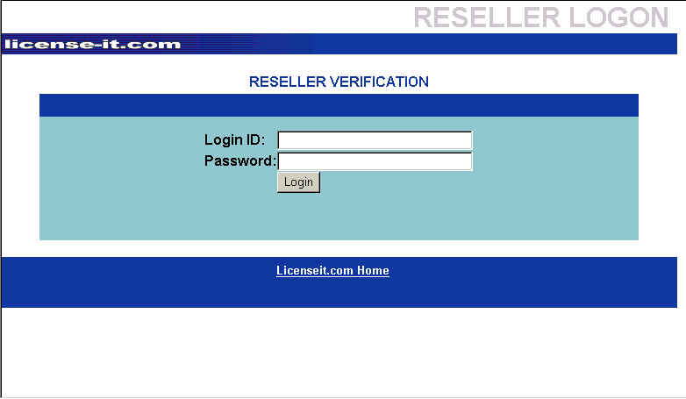

Figure 2

Enter the Login ID and Password exactly as you have registered it with KarlNet, then click the Login button. A window similar to the following is displayed:

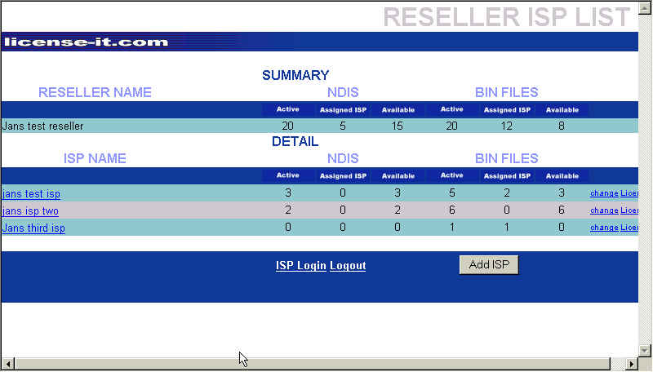
Figure 3
This window shows a summary of NDIS drivers and BIN files at the Reseller level, and a detail breakdown for the ISPs associated with the Reseller. In this example, 20 NDIS drivers have been assigned to this Reseller, 5 of them have been assigned to ISPs, and 15 are still available. Likewise, 20 BIN files have been assigned to the Reseller, 12 have been assigned to ISPs, and 8 are still available for assignment. There are three ISPs that have been associated with this reseller, and the number of active, assigned, and available NDIS drivers and BIN files for each is shown.

Resellers can use this window to add an ISP, change the information about an existing ISP, or to change the license information of the NDIS drivers and/or BIN files for the ISPs. To add an ISP, click the Add ISP button. A window similar to the following is displayed:
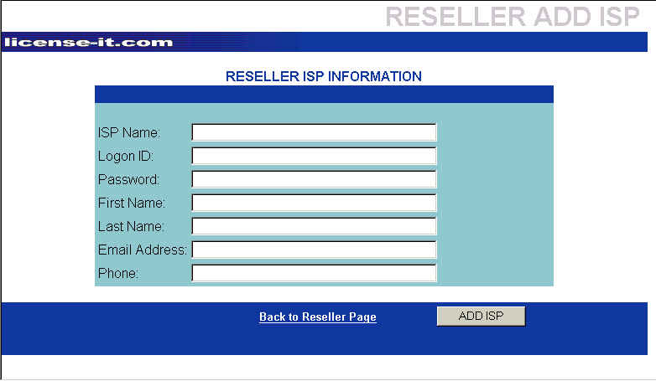
Enter the information about the ISP, then click the ADD ISP button. The new ISP will be added to the Reseller page, making it possible to assign licenses to it.
Figure 4

Notes: All fields require an entry. Numeric characters are not permitted in the ISP name.

If you want to display information about an ISP, select the ISP name from the list displayed (see Figure 3), then click the right mouse button. A window similar to the one below is displayed. This window is not editable - no changes can be made from this window.
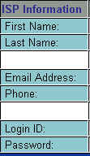
Figure 5
(Note: The actual window displayed will include the information that has been entered for the ISP, including the password.)

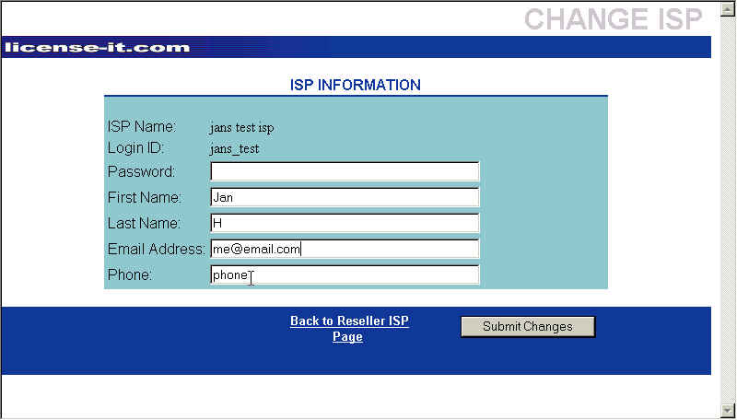
If you want to change contact information about the ISP, click the change button at the end of the line of the ISP you want to modify. A window similar to the following is displayed:
Figure 6

Using this window, you can change contact information such as name, email address or phone number. This window is also used to change the password used by the ISP. If changes are made, click the Submit Changes button, and the ISP information will be updated and you are returned to the summary page. If no changes are made/needed, click the Back to Reseller ISP Page label, or click the Back button on your browser.
You also use the window shown in Figure 3 to assign NDIS and BIN licenses to the ISP. To do this, click on the word License at the far right side of the line for the ISP you want to work with. A window similar to the following is displayed:
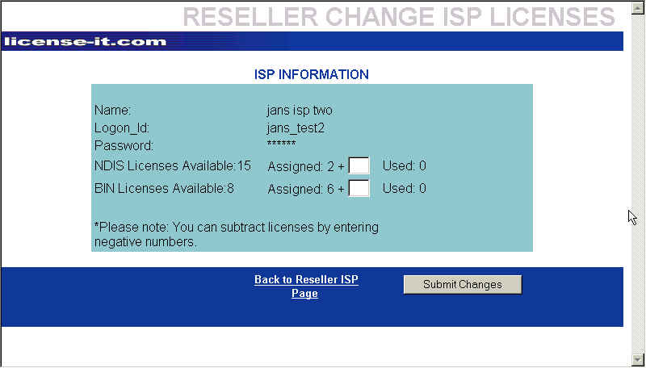
Figure 7
This window shows the number of licenses available (both NDIS and BIN), the number of licenses that have been assigned to the ISP, and the number of licenses that have been used - in other words, the number for which the key has been generated. To assign licenses to an ISP, enter the number in the appropriate box (NDIS or BIN), then click the Submit Changes button.

You can also retract licenses you have previously assigned to the ISP by entering a negative number in the appropriate box. When the Submit Changes button is clicked, the number will be subtracted and the numbers will be adjusted accordingly.

If you do not want to make any changes in the number of licenses assigned to the ISP, click the Back to Reseller ISP Page label, or click your browsers Back button.

Once all the ISP information is entered and the licenses assigned, you need to log on to the application as the ISP in order to generate the key. Select ISP Login Page from the application home page (see Figure 1) or click the ISP Login label from the summary page (see Figure 3). A window similar to the following is displayed:
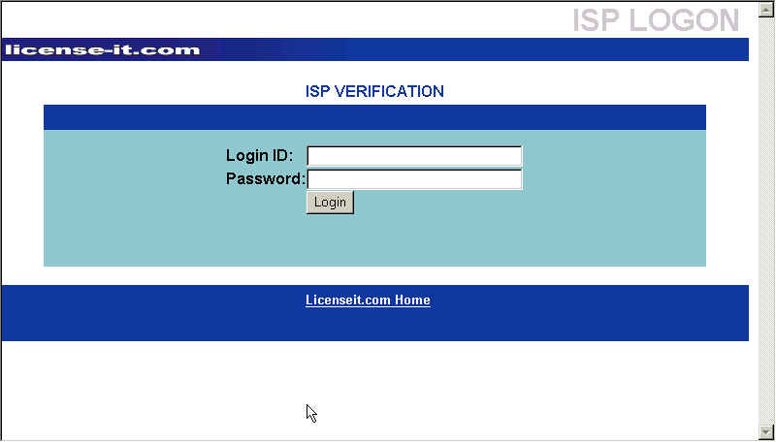

Figure 8

From this window, enter the ISP Login ID and password, then click the Login button. A window similar to the following is displayed:
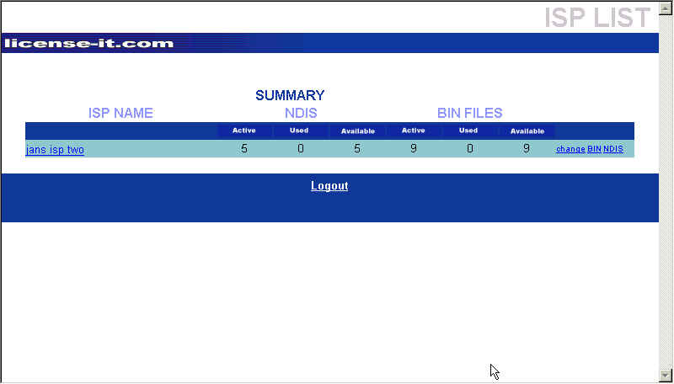
Figure 9
The window shows a summary for the ISP logged in to the application. Summary information includes the number of active, used, and assigned NDIS and BIN licenses. From this window you can display information about the ISP (see Figure 5 and associated text), change information about the ISP (see Figure 6 and associated text), or display information about the NDIS or BIN licenses assigned.

To display information about the NDIS licenses, click the word NDIS on the right hand side of the summary line. A window similar to the following is displayed:
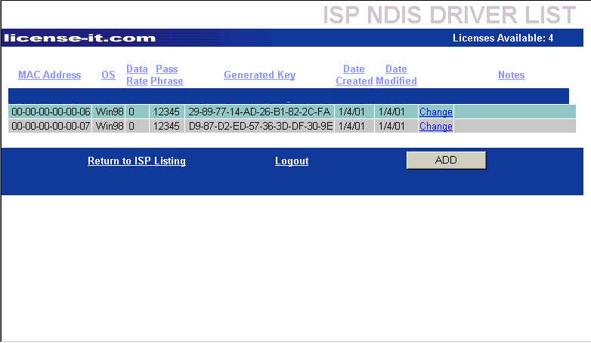
Figure 10
This window shows information about any keys that have already been generated for the NDIS licenses assigned to this ISP, the date the information was created and/or changed, as well as the number of licenses still available to this ISP. Using this window, you can change the key for the licenses already generated, or add additional keys, providing licenses are still available.

Note: Only NDIS licenses can be re-keyed online; to re-key BIN licenses, contact KarlNet support.

To change information about a license that has already had a key generated, click on the word change on the appropriate line. A window similar to the following is displayed:
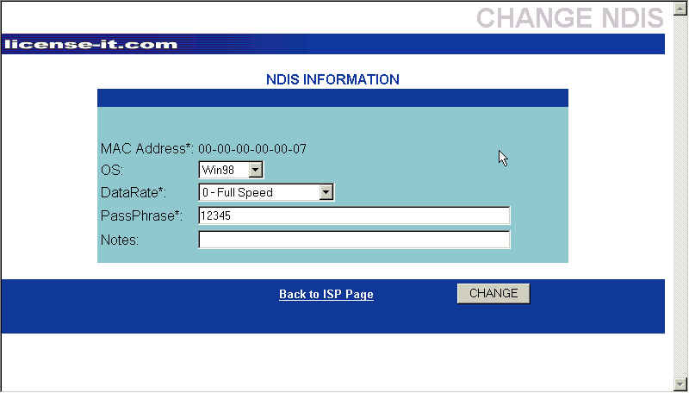
Figure 11

From this window you can change the operating system, the data rate, the password used with this license, or add some informational notes. You cannot change the MAC address associated with the license. Once the desired changes have been made, click the CHANGE button. A new key will be generated and displayed in the NDIS Drivers List window (see Figure 10).

To generate a key for an unused (but available) license, click the ADD button from the window displayed in Figure 10. A window similar to the following is displayed:
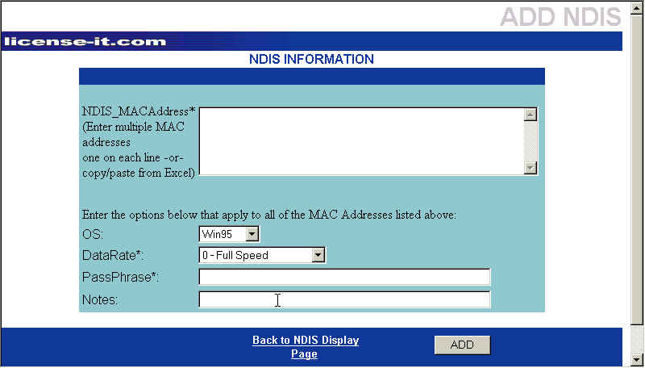
Figure 12
This window allows you to enter the information necessary to generate the key to make the NDIS license usable.

To generate a key, enter the MAC address in the box in the upper portion of the window. You can specify a single MAC address, or multiple MAC addresses, but be aware that all addresses will use the same criteria (operating system, data rate, password) entered in the lower portion of the window. If you want unique information for each license, enter a single MAC address and repeat the steps for each subsequent address. If you enter multiple addresses, each address must be entered on a separate line.

Note: If you have the MAC addresses listed in another application (i.e., Excel, Word), you can copy and paste the information into this box. The single address per line requirement still applies.

After entering the MAC address, select the operating system and date rate being used, enter the desired password and any notes, then click the ADD button. A key will be generated for each valid MAC address entered in the box and a window similar to the following is displayed:
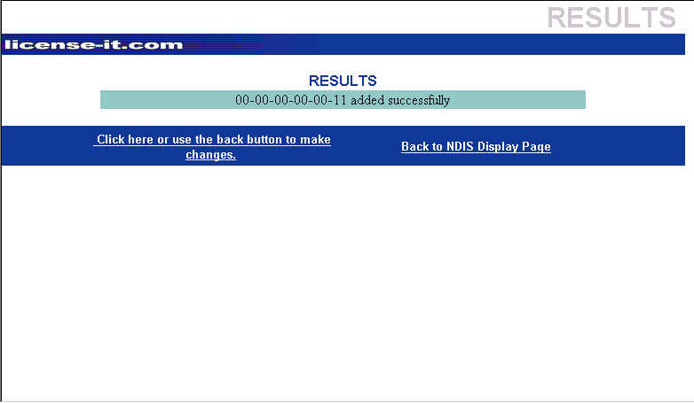
Figure 13

From this window you can make changes to the license just added or return to the NDIS Display page.

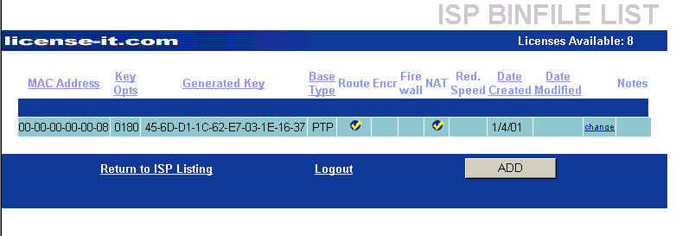
To add keys to BIN licenses, select the word BIN on the ISP summary window (Figure 9). If keys have already been generated for any licenses, a window similar to the following is displayed:

This window shows summary information about previously generated licenses (MAC address, key, features, etc.). Changes can only be made to the Notes section for any license displayed. Changes cannot be made for BIN files – you must contact KarlNet support.
Figure 14

Use this window to generate keys for available licenses. Click the ADD button. A window similar to the following is displayed:
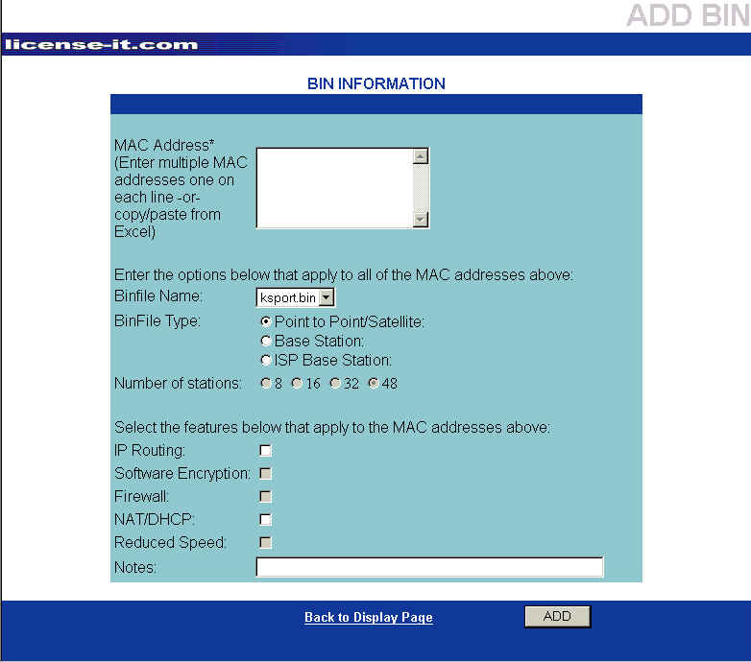
Figure 15

To generate a key, enter the MAC address in the box on the upper portion of the window. As with the NDIS licenses, multiple addresses can be entered (either by keying or by copying from another application) but all addresses will use the same criteria specified in the lower portion of the window.

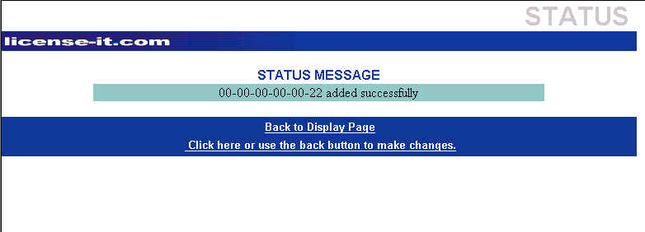
Select the Binfile name that will be used for this license, as well as the Binfile type and number of stations, if applicable. The features available with the Binfile selected will be enabled, allowing you to select desired features. Add any notes necessary, then click the ADD button. A window similar to the following is displayed:
If you need to make changes to any selection other than Notes, click on the bottom line to return to the previous window. Once you return to the Display page, only changes to the Notes can be made online. For all other changes with BIN files, you will need to contact KarlNet support.
Figure 16

Software Key Generation for ISPs

Copyright 2001 – KarlNet, Inc.
License-it.com

License-it.com is a web application that allows registered Resellers and ISPs to generate software keys for use with KarlNet NDIS drivers and configuration (bin) files. Access the program by entering http://206.21.0.66 from your internet browser. The following window will display:

Figure 17

Select ISP Login Page from the application home page (see Figure 1) or click the ISP Login label from the summary page (see Figure 3). A window similar to the following is displayed:

Figure 18

From this window, enter the ISP Login ID and password, then click the Login button. A window similar to the following is displayed:
Figure 19
The window shows a summary for the ISP logged in to the application. Summary information includes the number of active, used, and assigned NDIS and BIN licenses. From this window you can display information about the ISP (see Figure 5 and associated text), change information about the ISP (see Figure 6 and associated text), or display information about the NDIS or BIN licenses assigned.

To display information about the NDIS licenses, click the word NDIS on the right hand side of the summary line. A window similar to the following is displayed:
Figure 20
This window shows information about any keys that have already been generated for the NDIS licenses assigned to this ISP, the date the information was created and/or changed, as well as the number of licenses still available to this ISP. Using this window, you can change the key for the licenses already generated, or add additional keys, providing licenses are still available.

Note: Only NDIS licenses can be re-keyed online; to re-key BIN licenses, contact KarlNet support.

To change information about a license that has already had a key generated, click on the word change on the appropriate line. A window similar to the following is displayed:
Figure 21

From this window you can change the operating system, the data rate, the password used with this license, or add some informational notes. You cannot change the MAC address associated with the license. Once the desired changes have been made, click the CHANGE button. A new key will be generated and displayed in the NDIS Drivers List window (see Figure 10).

To generate a key for an unused (but available) license, click the ADD button from the window displayed in Figure 10. A window similar to the following is displayed:
Figure 22
This window allows you to enter the information necessary to generate the key to make the NDIS license usable.

To generate a key, enter the MAC address in the box in the upper portion of the window. You can specify a single MAC address, or multiple MAC addresses, but be aware that all addresses will use the same criteria (operating system, data rate, password) entered in the lower portion of the window. If you want unique information for each license, enter a single MAC address and repeat the steps for each subsequent address. If you enter multiple addresses, each address must be entered on a separate line.

Note: If you have the MAC addresses listed in another application (i.e., Excel, Word), you can copy and paste the information into this box. The single address per line requirement still applies.

After entering the MAC address, select the operating system and date rate being used, enter the desired password and any notes, then click the ADD button. A key will be generated for each valid MAC address entered in the box and a window similar to the following is displayed:
Figure 23

From this window you can make changes to the license just added or return to the NDIS Display page.

To add keys to BIN licenses, select the word BIN on the ISP summary window (Figure 9). If keys have already been generated for any licenses, a window similar to the following is displayed:

This window shows summary information about previously generated licenses (MAC address, key, features, etc.). Changes can only be made to the Notes section for any license displayed. Changes cannot be made for BIN files – you must contact KarlNet support.
Figure 24

Use this window to generate keys for available licenses. Click the ADD button. A window similar to the following is displayed:
Figure 25

To generate a key, enter the MAC address in the box on the upper portion of the window. As with the NDIS licenses, multiple addresses can be entered (either by keying or by copying from another application) but all addresses will use the same criteria specified in the lower portion of the window.

Select the Binfile name that will be used for this license, as well as the Binfile type and number of stations, if applicable. The features available with the Binfile selected will be enabled, allowing you to select desired features. Add any notes necessary, then click the ADD button. A window similar to the following is displayed:
If you need to make changes to any selection other than Notes, click on the bottom line to return to the previous window. Once you return to the Display page, only changes to the Notes can be made online. For all other changes with BIN files, you will need to contact KarlNet support.
Figure 26

