Comparative Analysis of Different Media Access Methods in
Metropolitan Area Networking.

The goal of this analysis was the application of 802.11b-based equipment in metropolitan area networking design.
It is commonly known that 802.11b was created for indoor application with short distance interaction between active devices concurrently with low noise level. One of the important features of such networks is full connectivity when all or a majority of devices can hear base station transmission and each other.
The media access method used is CSMA/CA (Carrier Sense Multiple Access with Collision Avoidance).
Carrier Sense is implemented as direct media listening before transmissions start,
Collision Avoidance is implemented as mandatory acknowledgement of every sent packet with repeating in fault case.
Necessity of media listening makes big sense for full network connectivity. The more sources that can hear each other the better synchronization can be achieved among them without collisions.
However it’s impossible to keep full connectivity in city area networking as there is shortage of frequency range, a big number of nodes and large distances or obstructions between nodes. Such networks are designed with sectors uniting the base station and single nodes in a cell. To minimize influence of outside noise and neighbor cells, directional antennas are used to point precisely at the base station.
In this case, a complicated situation arises when nodes can only hear the base station but not hear each other. This situation is known as “hidden node”.
802.11 standard attempts to solve this problem with a media reservation mechanism that utilizes special short packets (RTS/CTS) that are sent from every station before main packet transmission. The short packet contains information about the transmission query and its duration. When such a query (RTS) is sent by base station all other nodes process it and postpone transmission until the base station ceases activity. Theoretically, when a node sends it’s own transmission query (RTS), the other nodes that don’t hear the query postpone their own transmissions when they hear the base station acknowledgement (CTS).
This mechanism is questionable as the number of packages in media grows greatly, packets can become broken and/or lost when multiple nodes send different transmission queries.
A polling-based algorithm radically solves the hidden node problem by changing of media access method. A specially developed adaptive mechanism of querying (polling) saves network from sudden access chaos.
No one node can start transmission before it receives special acknowledgement packet (marker) from base station. The Adaptive algorithm minimizes the quantity of service information transmitted among the network by the regulation of marker frequency sending for every node depending on its activity and overall network load.
To compare the effectiveness of the two different media access methods, a test scheme was created consisting of a base station and four nodes. With the help of special cables, circulators and attenuators, a hidden node situation was simulated where all nodes could hear base station but couldn’t hear each other.
In DBS (Distributed Benchmark Systems) 4 TCP streams were started in different directions. The Main measurement parameters were uniformity, dynamics and the average speed of streams.
Each test lasted for 5 minutes (300 seconds). Test mutual dynamics influence streams were shifted in time and in duration relative to each other.
- TCP stream 1 begins from transmission start and lasts throughout the test
- TCP stream 2 starts after 30 second and lasts throughout the test
- TCP stream 3 starts after 60 seconds and lasts to the 200 second mark
- TCP stream 4 starts after 90 seconds and lasts to the 250 second mark
All tests have perfect recurrence and were performed several times.

Measurement results were graphed in the charts below, the left column shows the standard CSMA/CA mechanism, the right column shows a polling-based mechanism.

4 Streams to Nodes

CSMA/CA | Polling
EMBED Word.Picture.8 | 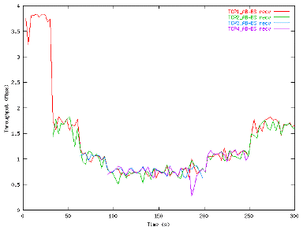

Since every node can clearly hear the base station and can control its own action, the hidden node problem doesn’t exist in the case of downstream transmissions. This is the ideal case for the CSMA/CA mechanism. However, o speed irregularity and suppression between differing streams occurs. Never the less, performance is much higher (~5.5Mbit/sec) utilizing CSMA/CA than using a polling mechanism (~4Mbit/sec). This result is not surprising due to the higher overhead the polling mechanism must maintain as opposed to CSMA/CA.

3 Streams to Nodes and 1 Stream to Base Station

CSMA/CA | Polling
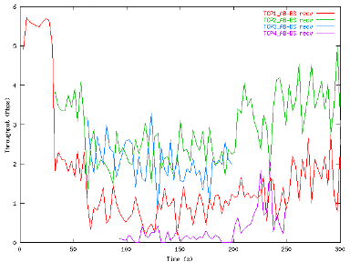 | 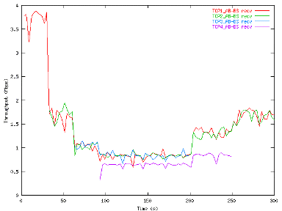

The first active stream to the base station drastically changes the chart’s appearance. The CSMA/CA stream speeds begin to vary dangerously. One can see a collapse and stoppage of certain streams. The polling-based mechanism is not significantly affected in this situation. The slightly lower counter stream speed can be explained by the polling algorithm’s prioritization of streams to nodes in order to maximize the output queues on the base station.

2 Streams to Nodes and 2 Streams to Base Station

CSMA/CA | Polling
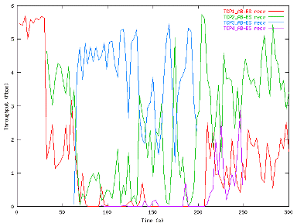 | 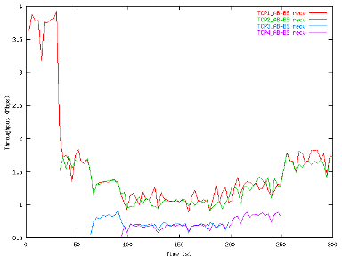

In CSMA/CA, the speed irregularities from the two counter streams create disaster. One should note that the system fluctuates dangerously, with periods of complete blocking due to excessive collisions. The polling-based mechanism shows a much better picture. Overall load stays at 4 Mbps with streams balancing uniformly. The difference in upstream and downstream transmission rates is explained by the algorithms stream prioritization.
1 Stream to Node and 3 Streams to Base Station

CSMA/CA | Polling
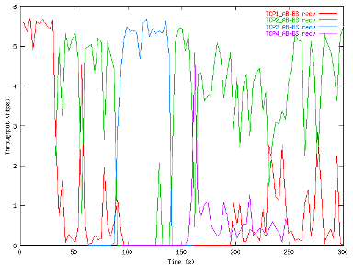 | 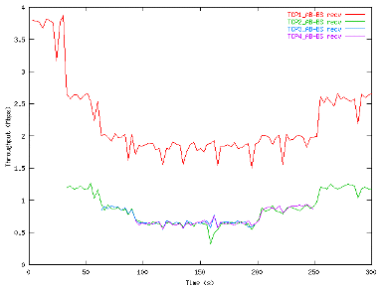

There isn’t much to say. CSMA/CA is having problems. A polling mechanism is capable of maintaining system stability.

4 Streams to Base Station

CSMA/CA | Polling
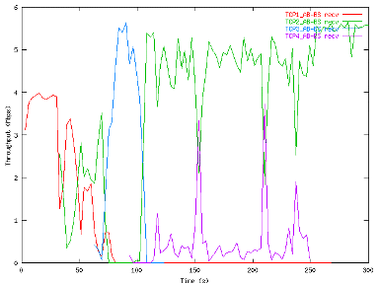 | 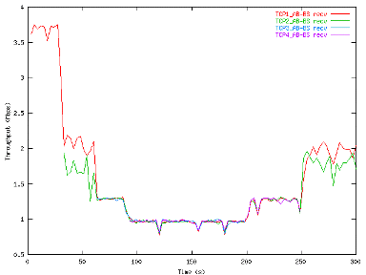

with RTS/CTS
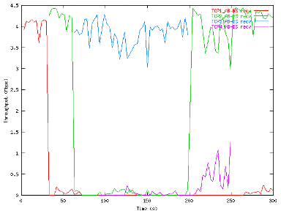

Transmission degradation with the CSMA/CA mechanism is so horrible that one needs to question the use of CSMA/CA for outdoor deployments. Turning on media reservation mechanism, which does decrease the maximum packet size transmitted, didn’t seem to help. Maximum speeds decrease, but the problem still is not solved. A polling-based mechanism remains relatively unaffected (compared with the first test) by the difference in streams.

Full Network Load. 4 Streams to Base Station and 4 Streams to Nodes

CSMA/CA | Polling
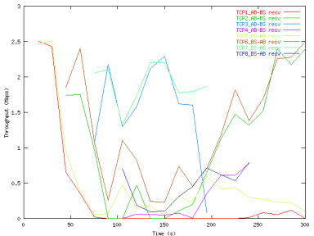 | 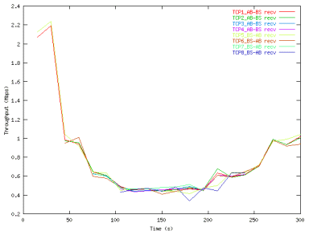
CSMA/CA in detail | Polling in detail
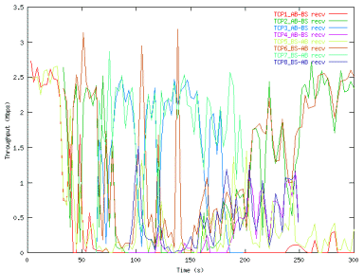 | 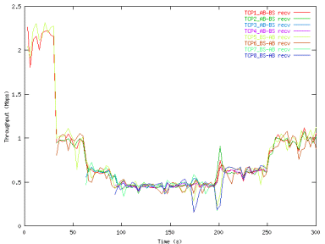

This simulates a fully loaded system operating in a city area network. The first two charts use a 15 second integration interval to show stream dynamics in a more visual way. The bottom charts use a 3 second integration interval. An interesting point to note is that the devices with slightly higher signal amplitude (TCP2 and TCP6 streams) suppressed weaker device amplitudes (TCP1 and TCP5 streams). This is typical for DSSS devices utilizing the CSMA/CA mechanism.

In Summary

- The above tests visually show how different media access methods perform in conditions similar to city area networking.

- The CSMA/CA method is best used for the conditions for which it was designed – internal networks with full connectivity. It is also possible to use CSMA/CA for city area networking with low node density, highly asymmetric activity, or for point-to-point backbone connections.

- CSMA/CA’s higher maximum speeds make this method more attractive to clients. However high stream irregularity coupled with the potential for total stream breakage makes it impossible to design scalable commercial networks with any QoS level.

- A polling-based mechanism solves the hidden node problem but costs up to a potential 25% of the theoretical maximum network speed due to increased overhead. However, a polling-based mechanism allows one to build a highly scalable and available network, allowing one to plan overall network load and capacity for clients at a guaranteed QoS level.

