Inhibit Private NAT

IP Conflicts
There are some network topologies where using NAT may cause potential IP conflicts. Assume we have the network topology below:
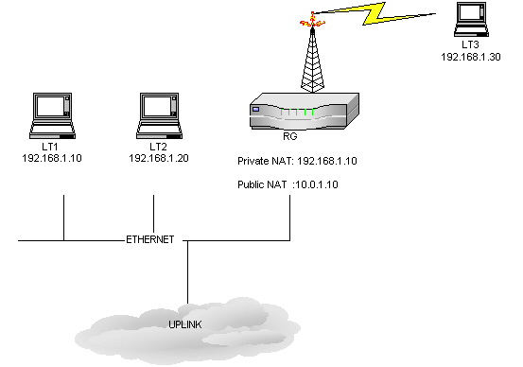
Figure 1
When LT2 tries to ping 192.168.1.10 , it will send out an ARP request for 192.168.1.10 IP address and either LT1 or RG will respond to that ARP request. If RG responds faster than LT2 will issue the ping using the MAC address for RG and 192.168.1.10. When the packet is sent out from LT2, LT1 will get an IP conflict. So there is a race condition and depending on either LT1 or RG responds to the ARP request, the ping will be issued to that unit and the other unit will get an IP conflict.

Inhibit NAT To Avoid IP Conflicts
A new feature is implemented in the kernel to avoid the IP conflicts as described in the above scenario. The idea is to block the private NAT side of the RG from the desired interface so that RG will not use its private IP address for any communication through that particular interface.
To apply the new feature , open the configuration of the RG, go to the Outgoing Network Address Translation Dialog under the setup menu and select the interface through which you want to inhibit ( block) the private NAT IP traffic.
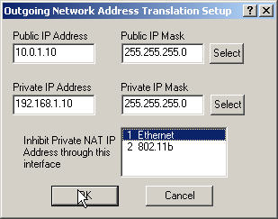
Figure 2
In our case, we don’t want the RG to respond to the ARP requests that come to its Ethernet interface and that are destined to 192.168.1.10 so we block the private NAT IP on Ethernet. That’s all what we needed. We can save back the configuration to the RG. With this configuration, we should not see any IP conflicts when we try to ping LT1 from LT2.

Karlnet SCAN Replies
When you scan RG from LT2 or LT1 , the scan will show RG having the IP address 192.168.1.10. And reason for that is the RG will reply with its private IP address if you issue a scan request from the IP address that’s in the Private NAT IP Subnet range. IF you hook another laptop to the Ethernet backbone above with an IP, say 20.20.20.20 then the scan will show RG with the IP address 10.0.1.10, which is the public NAT IP address. In our case above, we don’t want to see 192.168.1.10 in our scan reply when we scan the box from LT1 or LT2. So configuring the inhibit NAT feature on Ethernet (Figure 2) will solve that problem as well. Now we should always see 10.0.1.10 as the RG IP address if we scan from Ethernet with any IP address.

