Mod procedure – see picture and text below.
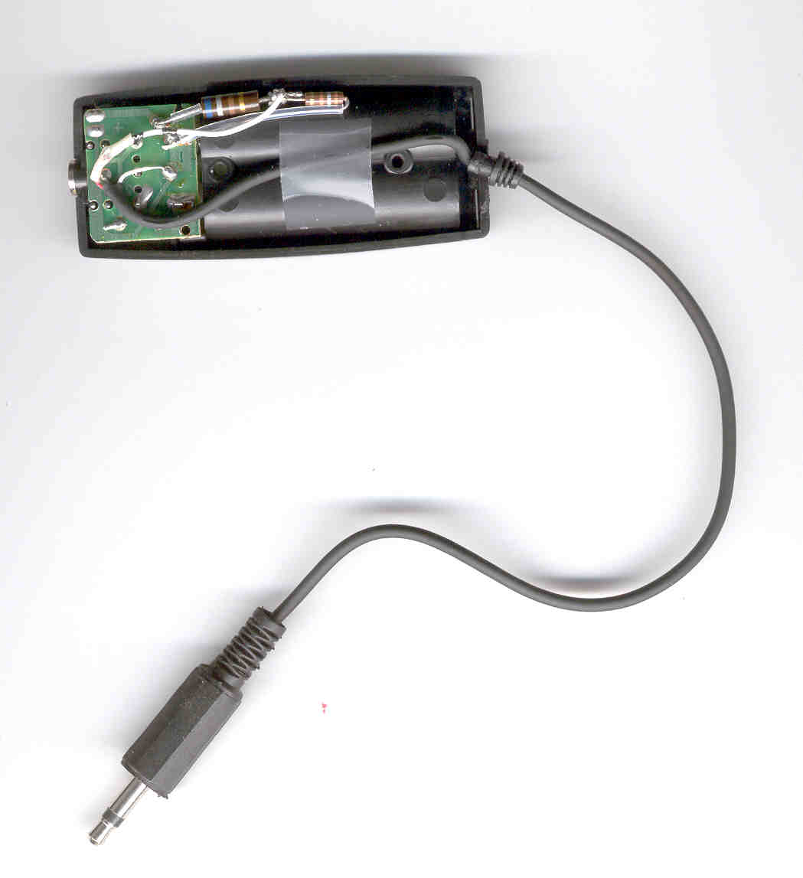
Point 1 – TX Audio
Point 2 - Gnd
680 Ohm
2-Conductor 1/8” Phone Plug
180 Ohm
Mod procedure.
- Needed Items – 680 ohm 1/4w resistor, 180 ohm 1/4w resistor, 1/8” 2-conductor phone plug, 2” piece of small wire, small heat shrink.
- Open up supplied Yamaha Headset Battery box by removing 2 phillips scres inside – where batteries go. Remove rear cover.
- Unsolder Red wire from Point 1 below.
- Solder 680 ohm and 180 ohm resistors in series – strip and solder one end of 2” piece of wire to junction of resistors.
- Solder unattached end of 680 ohm resistor to Point 1 below – where Red wire was removed.
- Solder unattached end of 180 ohm resistor to Point 2 below – this is ground.
- Strip unattached end of 2” piece of wire and put 3/8” piece of small heat shrink over wire. Solder Red wire removed in Step 3 above to end of 2” piece of wire. Shrink heat shrink over solder joint.
- Reassemble Yamaha Headset Battery box.
- Cut 1/8” 3-conductor plug off end of +/- 6” wire on Yamaha Battery box. Strip off insulation and Snip Black wire – not used. Strip ends of White and Red wires and tin with solder. Slip cover for new 1/8” 2-conductor plug over wire, then solder plug to White & Red wires. Red goes to Center / Tip of plug – White goes to Ring / Ground of plug.
- Enjoy…

